List of Tables and Figures

|  |  |  |  |
| --- | --- | --- | --- |
| Table 1  *Relationships Between News Attraction Variables and Non-Social Media News Use* | | | |
|  | Non-Social Media News Use | | | |
| **Fixed Effects** | β | *SE* | | |
| Intercept | 0.49*** | 0.08 | | |
| **Social Media as News Source (1 = Yes)** | **0.19\*\*\*** | **0.04** | | |
| **Self-Reported Interest** | **0.21\*\*\*** | **0.02** | | |
| **Follow Accounts for News** | **0.33\*\*\*** | **0.02** | | |
| **Algorithmic Categorization (1 = Interested)** | **0.29\*\*\*** | **0.04** | | |
| Age | -0.03** | 0.01 | | |
| Gender (1 = Female) | -0.13*** | 0.03 | | |
| Race (1 = Person of Color) | 0.00 | 0.03 | | |
| Education | 0.05*** | 0.01 | | |
| Income | 0.05*** | 0.01 | | |
| Ideology (+ Conservative) | 0.00 | 0.01 | | |
| Party Identity (+ Republican) | -0.01 | 0.01 | | |
| **Random Effects** | *Var.* | *SD* | | |
| InterceptFrame | 0.01 | 0.10 | | |
| Residual | 0.51 | 0.72 | | |
| **Fit Statistics** |  | |  | |
| ICC | .02 | | | |
| LL | -2,454.96 | | | |
| Pseudo-*R*2 | .54 | | | |
| *Note*: Cell entries are parameter estimates from linear multilevel model with random intercepts. Data are weighted by education and income. *N* = 2,008. Groups = 17. | | | |

|  |  |  |  |  |  |  |  |  |  |  |  |  |
| --- | --- | --- | --- | --- | --- | --- | --- | --- | --- | --- | --- | --- |
| Table 2  *Relationships Between News Attraction Variables and News Exposure Outcomes* | | | | | | | | | | | | |
|  | Incidental Exposure | | | | | | Total Exposure | | | Story Exposure | | |
|  | Trait-Like Variable | | | State-Like Variable | | | Trait-Like Variable | | | State-Like Variable | | |
| **Fixed Effects** | β | | *SE* | β | | *SE* | β | | *SE* | β | | *SE* |
| Intercept | 0.04 | | 0.12 | -2.56*** | | 0.28 | -0.88*** | | 0.11 | -2.32*** | | 0.21 |
| **SM as News Source (1 = Yes)** | **-0.30\*\*\*** | | **0.06** | **-0.05** | | **0.12** | **0.10** | | **0.05** | **0.22\*** | | **0.09** |
| **Self-Reported Interest** | **0.00** | | **0.03** | **0.05** | | **0.06** | **0.12\*\*\*** | | **0.02** | **0.06** | | **0.04** |
| **Follow Accounts for News** | **-0.09\*\*** | | **0.03** | **0.01** | | **0.06** | **0.12\*\*\*** | | **0.03** | **0.08** | | **0.05** |
| **Alg. Cat. (1 = Interested)** | **-0.20\*\*\*** | | **0.06** | **0.20** | | **0.11** | **-0.04** | | **0.05** | **0.36\*\*\*** | | **0.09** |
| Age | 0.08*** | | 0.02 | 0.12*** | | 0.04 | 0.05*** | | 0.02 | 0.03 | | 0.03 |
| Gender (1 = Female) | 0.01 | | 0.05 | -0.14 | | 0.10 | -0.07 | | 0.04 | -0.21** | | 0.08 |
| Race (1 = Person of Color) | -0.08 | | 0.05 | -0.11 | | 0.10 | -0.20*** | | 0.04 | -0.03 | | 0.08 |
| Education | 0.06*** | | 0.02 | 0.01 | | 0.03 | 0.04** | | 0.01 | 0.01 | | 0.02 |
| Income | -0.01 | | 0.01 | -0.05 | | 0.03 | -0.01 | | 0.01 | -0.03 | | 0.02 |
| Ideology (+ Conservative) | -0.03*** | | 0.01 | -0.03 | | 0.02 | -0.02** | | 0.01 | 0.01 | | 0.01 |
| Party Identity (+ Republican) | 0.06*** | | 0.01 | 0.03 | | 0.03 | 0.05*** | | 0.01 | 0.00 | | 0.02 |
| Frequency of Social Media Use | 0.05*** | | 0.01 | 0.08** | | 0.03 | 0.04** | | 0.01 | 0.00 | | 0.02 |
| Network Size | -0.11 | | 0.07 | -0.18 | | 0.15 | 0.27*** | | 0.07 | 0.15 | | 0.11 |
| Network Diversity | 0.17 | | 0.10 | -0.04 | | 0.22 | 0.18 | | 0.09 | 0.29 | | 0.15 |
| Group Activity | 0.21*** | | 0.05 | 0.10 | | 0.10 | 0.22*** | | 0.04 | 0.06 | | 0.07 |
| Social News Curation | 0.42*** | | 0.03 | 0.16* | | 0.07 | 0.45*** | | 0.03 | 0.18*** | | 0.05 |
| **Random Effects** | *Var.* | | *SD* | *Var.* | | *SD* | *Var.* | | *SD* | *Var.* | | *SD* |
| InterceptFrame | 0.01 | | 0.08 | 0.04 | | 0.20 | 0.01 | | 0.10 | 0.03 | | 0.18 |
| Residual | 0.99 | | 0.99 |  | |  | 0.86 | | 0.92 |  | |  |
| **Fit Statistics** |  |  | |  |  | |  |  | |  |  | |
| ICC | .01 | | | .03 | | | .01 | | | .02 | | |
| LL | -3,113.54 | | | -1,059.99 | | | -2,974.97 | | | -1,332.75 | | |
| Pseudo-*R*2 | .19 | | | .09 | | | .50 | | | .09 | | |
| *Note*: Cell entries are parameter estimates from multilevel models with random intercepts. Linear models are used for trait-like variables, and quasi-binomial models are used for state-like variables. Data are weighted by education and income. *N* = 2,008. Groups = 17. SM: Social media; Alg. Cat.: Algorithmic Categorization. | | | | | | | | | | | | |

|  |  |  |
| --- | --- | --- |
| Table 3  *Summary of Interaction Tests* |  |  |
| X * Incidental Exposure | Engagement | High-Effort Engagement |
| X: Social Media as News Source (1 = Yes) | *n.s.* | *n.s.* |
| X: Self-Reported Interest | *** | *** |
| X: Follow Accounts for News | *n.s.* | *n.s.* |
| X: Algorithmic Categorization (1 = Interested) | *n.s.* | *n.s.* |
| *Note:* Cell entries represent statistical significance of interaction coefficient. *** *p* < .001; *n.s.*: not significant. Full results available upon request. | | |

Figure 1

*Theoretical Relationships Among News Attraction, News Exposure, and News Engagement*



Figure 2

*Relationships Between News Attraction Variables and Incidental Exposure (Trait-Like)*

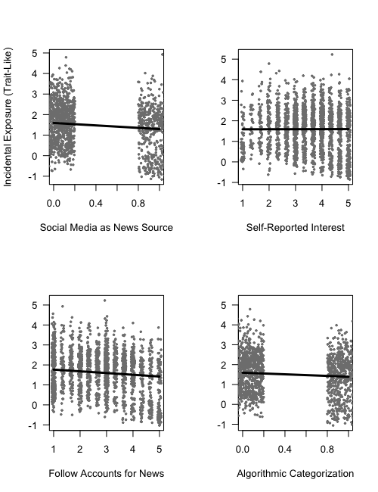

Figure 3

*Relationships Between News Attraction Variables and Incidental Exposure (State-Like)*

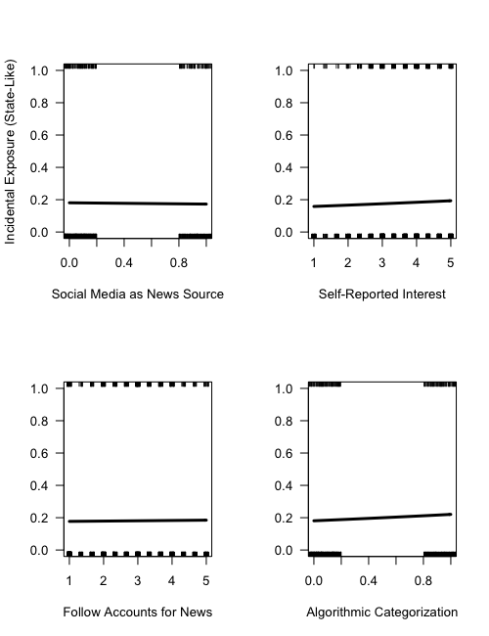

Figure 4

*Relationships Between News Attraction Variables and Total Exposure (Trait-Like)*

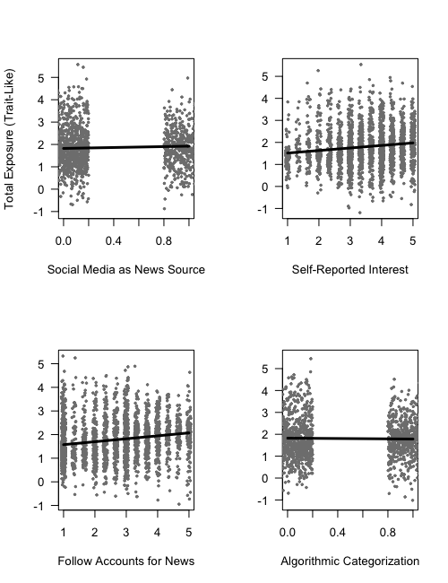

Figure 5

*Relationships Between News Attraction Variables and Story Exposure (State-Like)*

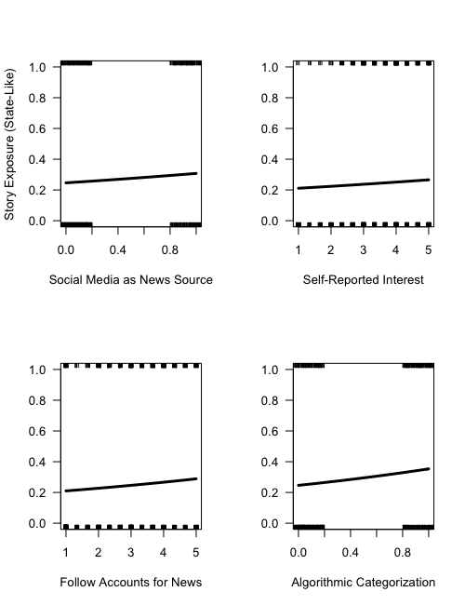

Figure 6

*Conditional Relationship Between Incidental Exposure and News Engagement at Various Levels of Self-Reported Interest*

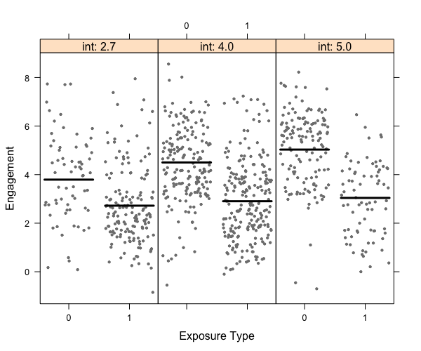

Figure 7

*Conditional Relationship Between Incidental Exposure and High-Effort News Engagement at Various Levels of Self-Reported Interest*

